How to enter an Equipment Distribution order in Lawson

In Lawson Go to OIS300 (Customer Order Open) screen:

In the customer box enter your customer number if you know it or search for it by hitting **F4** 2x

You will be brought to this screen. Make sure your sorting order in top right corner has “6-Name” selected. You will be sorting by the customer’s name.

Type in customer you are looking for in the “name” field. You can further filter by adding * asterisks around words in the same you want to search by. (useful if you are searching for a chain account and there are many)

Be sure to look at the STS field. If it is status 10 or 90 these are customer numbers that are not able to be used. Status 10 means it is not a fully completed customer record and 90 means it is no longer a viable customer record.

Status 20 is what should be used.

Right click on the customer and a menu will appear. Arrow down and pick “select”.

Customer Number you just selected will be in the customer number field.

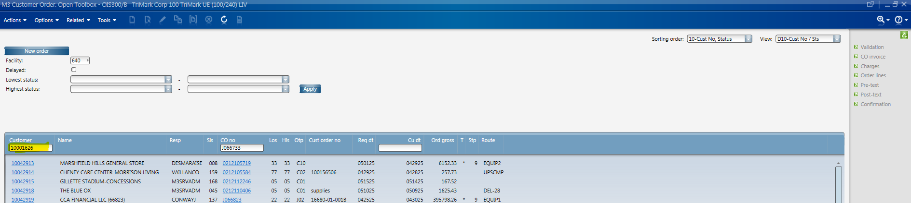

Hit Enter

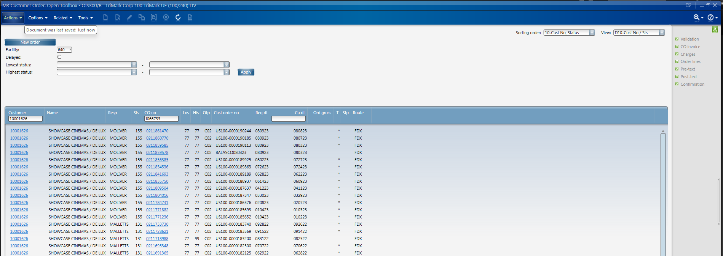

Select “new order” at the top left corner of screen.

In CO Type click in the field and Order Type options to select will come up. Right click on C09 then hit the Select button.

Make sure Panel Sequence is EFGH

You will see:

Click next in the bottom right corner of the screen

You will now be on Panel E:

The Requested delivery date must be entered here. If the customer does not need it for a month that date should be put in.

Hit Next - Next again.

In Panel F Change your Route to EQUIP2 if our truck and Comcar if not our truck

Hit Next

You will be at Panel G.

If this is a National/D&B or Street account, you can change your (or the correct persons) salesperson number.

If a PM is assigned, you must change the responsible “CO resp” to their name. If there is no PM, it will default to who is entering the order.

To change either field follow the process above. Click arrow in the field. Find your selection. Then hit the select button.

If you have had a customer PO, you would enter here the Customer Order No field.

Once complete hit next.

Here you will be in the order screen where you may enter multiple lines at a time or yu may also skip to panel Panel B and enter lines there also. (see Panel B below)

Reminder this is NOT an order yet.

Enter “Ln Tp” (line type) 1 for ship from here and 2 drop ship, QTY, BTO, Price. Tab from field to field and to the next line if you have multiple. When you are done entering lines select Create Order lines in the top right corner.

When entering safeware BTOs in order entry remember to select ltp2 as this is considered a service and will not be an item our warehouse will receive. This is important for purchasing and vendor invoicing. This BTO is derived from your AQ proposal that you have submitted to your customer. Cheat sheet for how to select can be found by clicking this link [Safeware Cheat Sheet 3.24.25.pptx](https://trimarkusa.sharepoint.com/:p:/s/a_UE_ProjectsTeams/EWYrVJAd2ORCsqvSRc5RlKgB_te_g7ggu3IKP4cRN9qGLg?e=6o6k2b) . Link to Safeware BTO [Safeware_Lawson_BTO_Number_Reference_Guide](https://trimarkusa.sharepoint.com/:b:/s/a_UE_ProjectsTeams/ESZu3GoP-pFOsVmOYyMZ98IBgnh1pfZH0XSl0T_vvg6wIQ?e=RSWRmk)

If this screen appears. Click Actions at top left corner and select “update”

Then “next” again in the next screen (OIS145/F)

You will see:

Answer yes if you are ok with system creating the planned date a few weeks out or NO if equipment is needed right away.

If you are on Panel B.

Enter information along the bottom of the screen as shown below.

LTP

Enter BTO number in “Item” field:

Qty, sell Price then hit add

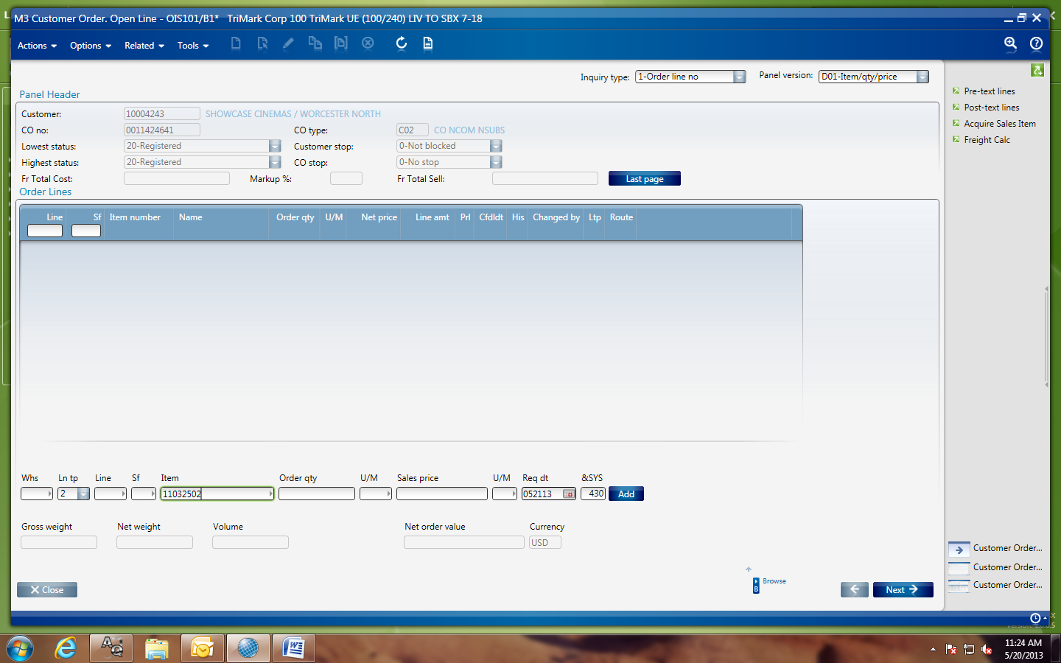

Your order number is the “CO number”

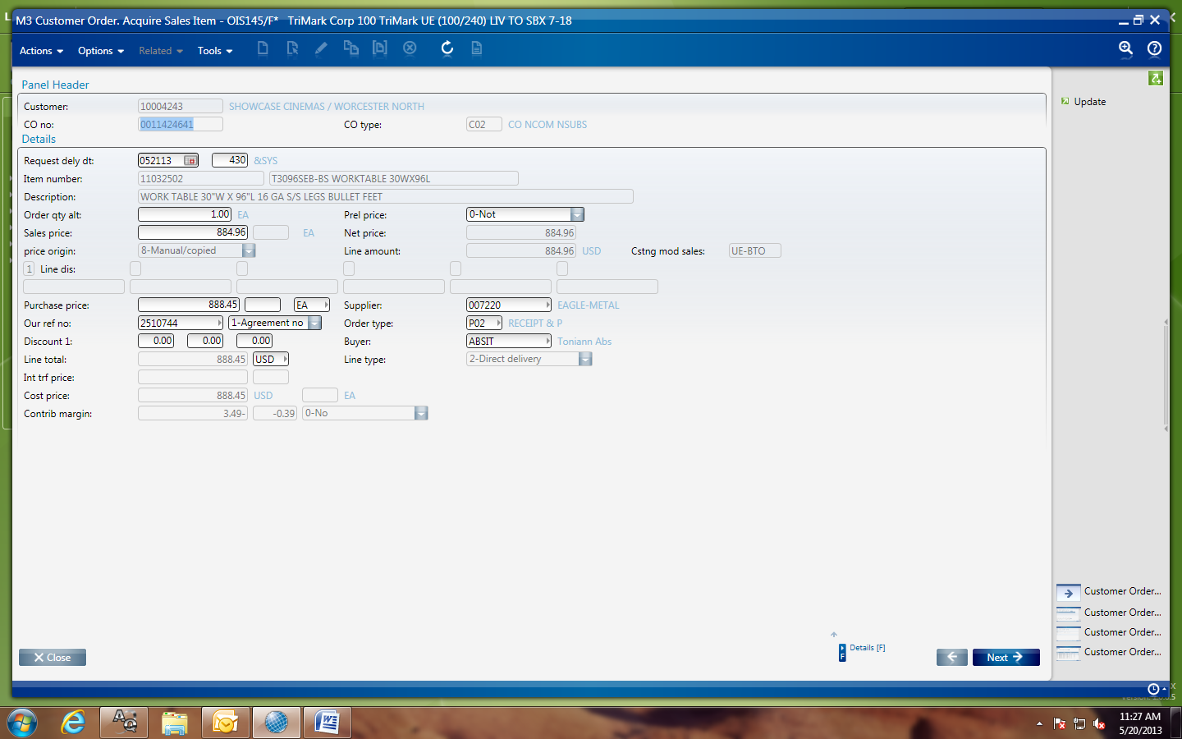

Now hit close for the order to be accepted!

If you forgot to change your shipping route at the beginning of order.

On the header level right click the order you just entered right click then select change:

Go to Panel OIS300/F and change the routing to be Equip2 – hit select and answer Yes to changing all order lines.

**Add how to enter freight charges**